1. **Equality Analysis** **(extract from the Policy on Policies)**
   1. Text for inclusion in every policy and procedure: **[The Trust believes in fairness and equality, and values diversity in its role as both a provider of services and as an employer. The Trust aims to provide accessible services that respect the needs of each individual and exclude no-one. It is committed to comply with the Human Rights Act and to meeting the Equality Act 2010, which identifies the following nine protected characteristics: Age, Disability, Race, Religion and Belief, Gender Reassignment, Sexual Orientation, Sex, Marriage and Civil Partnership and Pregnancy and Maternity.**
   2. **Compliance with the Public Sector Equality Duty: If a contractor carries out functions of a public nature then for the duration of the contract, the contractor or supplier would itself be considered a public authority and have the duty to comply with the equalities duties when carrying out those functions.]**
   3. Every policy and procedure must be accompanied by a completed and authorised Equality Analysis (EA). The guidance and template for completing this are below.
   4. Once the EA is complete, this guidance should be deleted from your policy and procedure and the completed EA retained within the document.
   5. Equality Analysis (EA) is a tool aimed at improving the quality of our services by ensuring that individuals and teams think carefully about the likely impact of their work on different communities or groups. It involves anticipating the consequences of the Trust’s policies, functions and services on different communities and making sure that any negative consequences are eliminated or minimised, whilst opportunities for promoting equality are maximised.
   6. Systematic and robust completion of EAs will assist us to comply with the Equality Act 2010 which places a duty on the Trust to have due regard to the need to:
      1. Eliminate discrimination, harassment and victimisation.
      2. Advance equality of opportunity between persons who share a relevant protected characteristic and persons who do not share it.
      3. Foster good relations between persons who share a relevant protected characteristic and persons who do not share it.
   7. These are known as the three aims of the general equality duty. The Act sets out nine **protected characteristics** that apply to the equality duty, which must be considered in the EA process. The protected characteristics are:

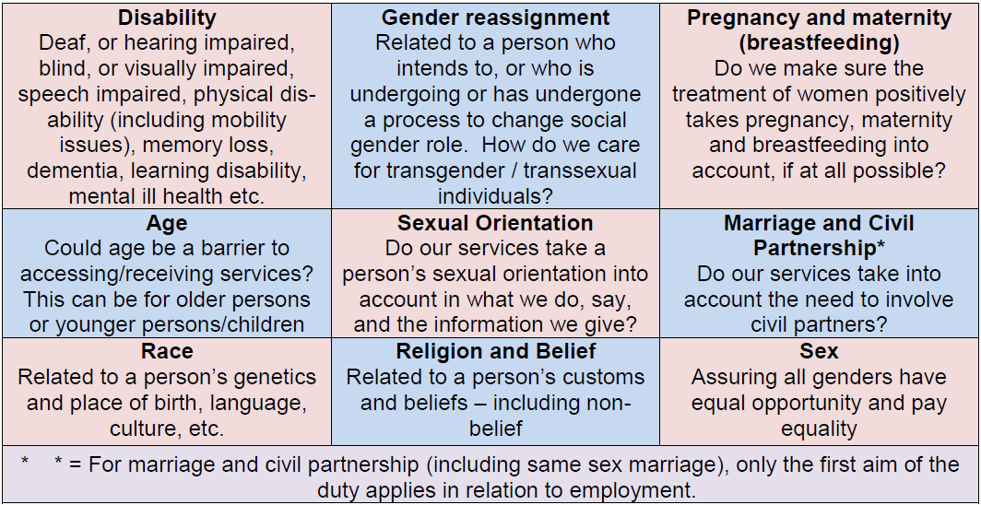

* 1. The flow chart below sets out the EA process:

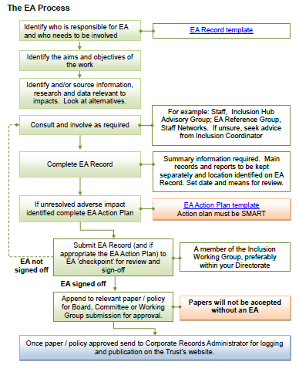

* 1. The EA form for completion is below. Depending on the outcome at this initial stage, an action plan may also be required. The template for actions is included below. Please contact [inclusion@secamb.nhs.uk](mailto:inclusion@secamb.nhs.uk) for support undertaking an EA.

|  |  |  |  |
| --- | --- | --- | --- |
| **Name of author and role** |  | | |
| **Directorate** |  | **Date of analysis:** |  |
| **Name of policy being analysed** |  | | |
| **Names of those involved in this EA** |  | | |

|  |  |  |
| --- | --- | --- |
| **1. Trust policies and procedures should support the requirements of the Equality Duty within the Equality Act:** | * Eliminate discrimination, harassment and victimisation; * Advance equality of opportunity between persons who share a relevant protected characteristic and persons who do not share it; * Foster good relations between persons who share a relevant protected characteristic and persons who do not share it. | In submitting this form, you are confirming that you have taken all reasonable steps to ensure that the requirements of the Equality Duty are properly considered. |

|  |  |  |
| --- | --- | --- |
| **2. When considering whether the processes outlined in your document may adversely impact on anyone, is there any existing research or information that you have taken into account?** | For example:   * Local or national research * National health data * Local demographics * SECAmb race equality data * Work undertaken for previous EAs | If so, please give details: |

|  |  |
| --- | --- |
| **3. Do the processes described have an impact on anyone’s human rights?** | If so, please describe how (positive/negative etc): |

|  |  |  |  |
| --- | --- | --- | --- |
| **4.** **What are the outcomes of the EA in relation to people with protected characteristics?** | | | |
| **Protected characteristic** | **Impact**  Positive/Neutral/Negative | **Protected characteristic** | **Impact**  Positive/Neutral/Negative |
| Age |  | Race |  |
| Disability |  | Religion or belief |  |
| Gender reassignment |  | Sex |  |
| Marriage and civil partnership |  | Sexual orientation |  |
| Pregnancy and maternity |  |  | |

|  |
| --- |
| **5. Mitigating negative impacts:** |
| If any negative impacts have been identified, an Equality Analysis Action Plan must be completed and attached to the EA Record. A template for the action plan is available in the [Equality Analysis Guidance](http://www.secamb.nhs.uk/staff_zone4/my_secamb/equality_and_diversity/equality_impact_assessments.aspx) on the Trust’s website. Please contact [inclusion@secamb.nhs.uk](mailto:inclusion@secamb.nhs.uk) for support and guidance. |

|  |  |  |  |  |
| --- | --- | --- | --- | --- |
| Protected characteristic: |  | Issue identified: |  | |
| Action required: |  | | | |
| Action lead: |  | | | |
| How will impact/outcome be measured? |  | Timescale: |  |  |
| Resolution of actions: |  | | | |

|  |  |  |  |  |
| --- | --- | --- | --- | --- |
| Protected characteristic: |  | Issue identified: |  | |
| Action required: |  | | | |
| Action lead: |  | | | |
| How will impact/outcome be measured? |  | Timescale: |  |  |
| Resolution of actions: |  | | | |

|  |  |  |
| --- | --- | --- |
| **EA Sign off** | | |
| EA checkpoint (Inclusion Working Group member, preferably from your Directorate) | [Name and role] | |
| By signing this, I confirm that I am satisfied the EA process detailed on this form and the work it refers to are non-discriminatory and support the aims of the Equality Act 2010 as outlined in section 1 above. | | |
| Signed: | | Date: |